**Lab: Associative Arrays**

Problems for exercise and homework for the ["JS Fundamentals" Course @ SoftUni.](https://softuni.bg/trainings/4096/programming-fundamentals-with-javascript-may-2023)

Submit your solutions in the SoftUni judge system at: <https://judge.softuni.org/Contests/1231>

**1. Phone Book**

Write a function that stores information about a **person’s name** and **phone number**. The input is an **array of strings** with space-separated name and number. **Replace duplicate names**. Print the result as shown.

**Example**

|  |  |
| --- | --- |
| **Input** | **Output** |
| **['Tim 0834212554',** | **Tim -> 0876566344** |
| **'Peter 0877547887',** | **Peter -> 0877547887** |
| **'Bill 0896543112',** | **Bill -> 0896543112** |
| **'Tim 0876566344']** |  |
| **['George 0552554',** | **George -> 0453112** |
| **'Peter 087587',** | **Peter -> 087587** |
| **'George 0453112',** | **Bill -> 0845344** |
| **'Bill 0845344']** |  |

**2. Meetings**

Write a function that manages meeting appointments. The input comes as an **array of strings**. Each string contains a **weekday** and person’s **name**. For each **successful** meeting, **print a message**. If you receive the **same weekday** twice,the meeting cannot be scheduled so print a **conflicting message**. In the end, print a list of all **successful** meetings.

**Example**

|  |  |  |
| --- | --- | --- |
| **Input** | **Output** |  |
| **['Monday Peter',** | **Scheduled for Monday** |  |
| **'Wednesday Bill',** | **Scheduled for Wednesday** |  |
| **'Monday Tim',** | **Conflict on Monday!** |  |
| **'Friday Tim']** | **Scheduled for Friday** |  |
|  | **Monday -> Peter** |  |
|  | **Wednesday -> Bill** |  |
|  | **Friday -> Tim** |  |
| **['Friday Bob',** | **Scheduled for Friday** |  |
| **'Saturday Ted',** | **Scheduled for Saturday** |  |
| **'Monday Bill',** | **Scheduled for Monday** |  |
| **'Monday John',** | **Conflict on Monday!** |  |
| **'Wednesday George']** | **Scheduled for Wednesday** |  |
|  | **Friday -> Bob** |  |
|  | **Saturday -> Ted** |  |
|  | **Monday -> Bill** |  |
|  | **Wednesday -> George** |  |
|  |  |  |



© SoftUni – [https://softuni.org.](https://softuni.org/) Copyrighted document. Unauthorized copy, reproduction or use is not permitted.



|  |  |  |
| --- | --- | --- |
| Follow us: | Page 1 of 5 |  |
|  |  |

**3. Address Book**

Write a function that stores information about a person’s **name** and his **address**. The input comes as an **array of strings**. Each string contains the **name** and the **address** separated by a **colon**. If you receive the same name **twice** just **replace** the address. In the end, print the full list, **sorted alphabetically** by the person’s name.

|  |  |  |  |
| --- | --- | --- | --- |
| **Input** |  | **Output** |  |
| **['Tim:Doe Crossing',** |  | **Bill -> Ornery Rd** |  |
| **'Bill:Nelson Place',** |  | **Peter -> Carlyle Ave** |  |
| **'Peter:Carlyle Ave',** |  | **Tim -> Doe Crossing** |  |
| **'Bill:Ornery Rd']** |  |  |  |
| **['Bob:Huxley Rd',** |  | **Bill -> Gateway Way** |  |
| **'John:Milwaukee** |  | **Bob -> Redwing Ave** |  |
| **Crossing',** |  | **George -> Mesta** |  |
|  |  |  |
| **'Peter:Fordem Ave',** |  | **Crossing** |  |
| **'Bob:Redwing Ave',** |  | **Jeff -> Huxley Rd** |  |
| **'George:Mesta** |  | **John -> Grover Rd** |  |
| **Crossing',** |  | **Peter -> Huxley Rd** |  |
|  |  |  |
| **'Ted:Gateway Way',** |  | **Ted -> Gateway Way** |  |
|  |  |  |
| **'Bill:Gateway Way',** |  |  |  |
| **'John:Grover Rd',** |  |  |  |
| **'Peter:Huxley Rd',** |  |  |  |
| **'Jeff:Gateway Way',** |  |  |  |
| **'Jeff:Huxley Rd']** |  |  |  |

**4. Storage**

Write a function that takes a certain number of **items** and their **quantity**. If the same item appears **more than once**, **add the new amount** to the **existing one**. In the end, print all the items and their amount without sorting them. Theinput comes as an **array of strings**. Try using a **Map()**.

**Example**

|  |  |
| --- | --- |
| **Input** | **Output** |
|  |  |
| **['tomatoes 10',** | **tomatoes -> 10** |
| **'coffee 5',** | **coffee -> 45** |
| **'olives 100',** | **olives -> 100** |
| **'coffee 40']** |  |
|  |  |
| **['apple 50',** | **apple -> 111** |
| **'apple 61',** | **coffee -> 155** |
| **'coffee 115',** |  |
| **'coffee 40']** |  |
|  |  |



© SoftUni – [https://softuni.org.](https://softuni.org/) Copyrighted document. Unauthorized copy, reproduction or use is not permitted.



|  |  |  |
| --- | --- | --- |
| Follow us: | Page 2 of 5 |  |
|  |  |

**Hints**

Create the **solve()** function and create a new **Map()**:

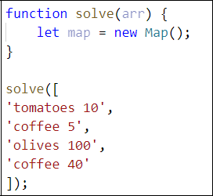

Loop through the array, split into tokens, and create variables for each one:

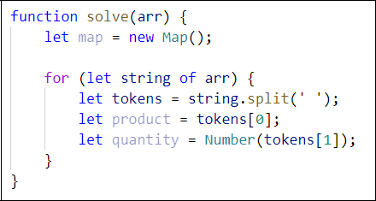

* This time for the quantity we need a number because if we see the same product again, we must add the new quantity

Now let us make the checks for the keys on the map:

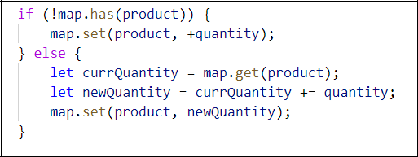

* First, we check if the map does ***NOT*** have the product we are currently at and **if so**, we **set it to the given quantity**
* Otherwise, we get the **existing quantity**, we **add the new quantity,** and **set** the product’s quantity **to the new** one



© SoftUni – [https://softuni.org.](https://softuni.org/) Copyrighted document. Unauthorized copy, reproduction or use is not permitted.



|  |  |  |
| --- | --- | --- |
| Follow us: | Page 3 of 5 |  |
|  |  |

Now we just have to print the result:

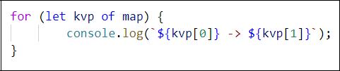

* + Each key-value pair is and an **array of 2 elements** (the **key** and the **value**), so we use a **for-of** loop and print the key and the value

1. **School Grades**

Write a function that stores **students** and their **grades** throughout the year. If a student appears more than once, **add** the new **grades** to **existing ones**. Finally, **print** the students and their **average grades**, sorted **alphabetically** by **student name.** The input comes as an **array of strings**.

**Note:** The **average grades** must be fixed to the second decimal place.

**Example**

|  |  |  |  |  |
| --- | --- | --- | --- | --- |
|  | **Input** | |  | **Output** |
| **['Lilly 4** | **665',** | | | **Lilly: 5.25** |
| **'Tim 5 6',** | |  |  | **Tammy: 3.00** |
| **'Tammy 2 4** | | **3',** |  | **Tim: 5.75** |
| **'Tim 6 6']** | |  |  |  |
|  | |  |  |  |
| **['Steven 3** | | **5 6** | **4',** | **George: 5.00** |
| **'George 4** | **6',** | |  | **Steven: 4.50** |
| **'Tammy 2 5** | | **3',** |  | **Tammy: 3.33** |
| **'Steven 6** | **3']** | |  |  |
|  |  |  |  |  |

**6. Word Occurrences**

Write a function that **counts** the times each **word occurs** in a text. Print the words **sorted by count** in **descending** order. The input comes as an **array of strings**.

**Example**

|  |  |  |  |  |  |  |
| --- | --- | --- | --- | --- | --- | --- |
|  | **Input** |  |  | **Output** | |  |
|  | **["Here", "is", "the", "first", "sentence",** |  | **sentence** | **-> 3 times** | |  |
|  | **"Here", "is", "another", "sentence", "And",** |  | **Here -> 2 times** | | |  |
|  | **"finally", "the", "third", "sentence"]** |  |  |
|  |  | **is -> 2 times** | | |  |
|  |  |  |  |
|  |  |  | **the -> 2** | **times** | |  |
|  |  |  | **first ->** | **1** | **times** |  |
|  |  |  | **another ->** | | **1 times** |  |
|  |  |  | **And -> 1** | **times** | |  |
|  |  |  | **finally ->** | | **1 times** |  |
|  |  |  | **third ->** | **1** | **times** |  |



© SoftUni – [https://softuni.org.](https://softuni.org/) Copyrighted document. Unauthorized copy, reproduction or use is not permitted.



|  |  |  |
| --- | --- | --- |
| Follow us: | Page 4 of 5 |  |
|  |  |

|  |  |  |  |  |
| --- | --- | --- | --- | --- |
| **Input** |  |  | **Output** |  |
| **["dog", "bye", "city", "dog", "dad",** |  | **dog -> 2 times** | |  |
| **"boys", "ginger"]** |  | **bye -> 1 times** | |  |
|  |  |  |
|  |  | **city -> 1** | **times** |  |
|  |  | **dad -> 1 times** | |  |
|  |  | **boys -> 1** | **times** |  |
|  |  | **ginger ->** | **1 times** |  |
|  |  |  |  |  |

**Hint**

* Create a map
* Loop through the elements of the array of words
* Update the map
* Sort the map by value in descending:
* Finally, print the result in the format as the example above



© SoftUni – [https://softuni.org.](https://softuni.org/) Copyrighted document. Unauthorized copy, reproduction or use is not permitted.



|  |  |  |
| --- | --- | --- |
| Follow us: | Page 5 of 5 |  |
|  |  |